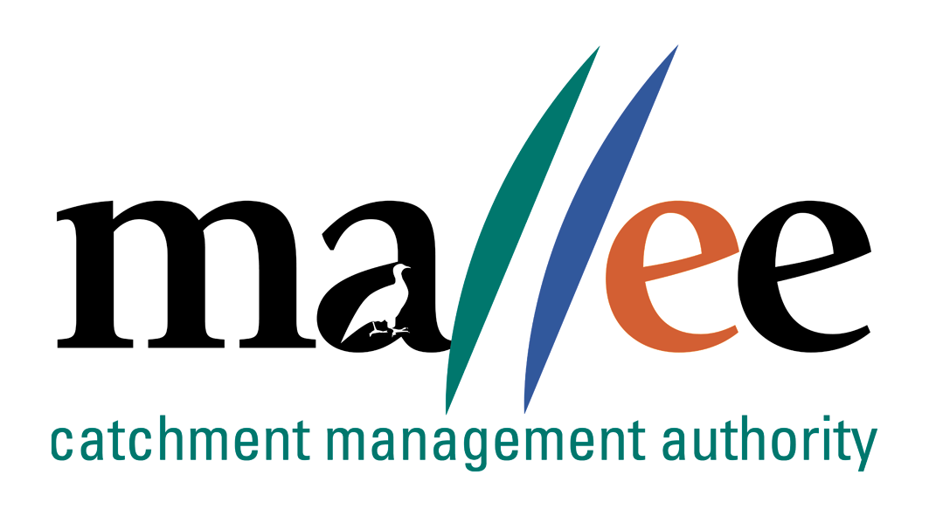 | APPLICANT RESPONSE FORM
Document Reference No: 025-321-FORM
Job Application Form
Please complete this form as part of your application.
In addition to this form you will also need to include a covering letter, a resume outlining education, employment history, copies of certificates / qualifications / licenses (as identified in the position description), details of 2 professional referees and any additional information relevant to the position.
You are encouraged to read the position description prior to completing this form. Reponses should include relevant and concise detail of how your current skills, attributes, knowledge and qualifications enable you to successfully fulfil the requirements of the position.
A maximum of 4 pages is preferred.
Position details
Vacancy reference number | 36/022
Position title | Project Coordinator Sustainable Agriculture
Position location | Negotiable
Applicant details
Name:
Email address:
Please note – all correspondence in relation to this application will be sent to your email address
Phone number:

SHORT ANSWER QUESTIONS
Applicants are to respond to the following questions:

- What was it about this role that prompted you to submit an application – especially in regards to what you will offer to the role and what you hope to get from the experience?

- Tell us about a project or task you have completed that required a particularly high degree of accuracy and/or attention to detail. What processes did you use to ensure that this requirement was achieved?

- What are the critical factors associated with successfully developing and delivering government funded dryland agriculture related programs?

- Utilising both verbal and written communication skills, how do you ensure you communicate effectively with a variety of audiences?

File action: Human resources application file

