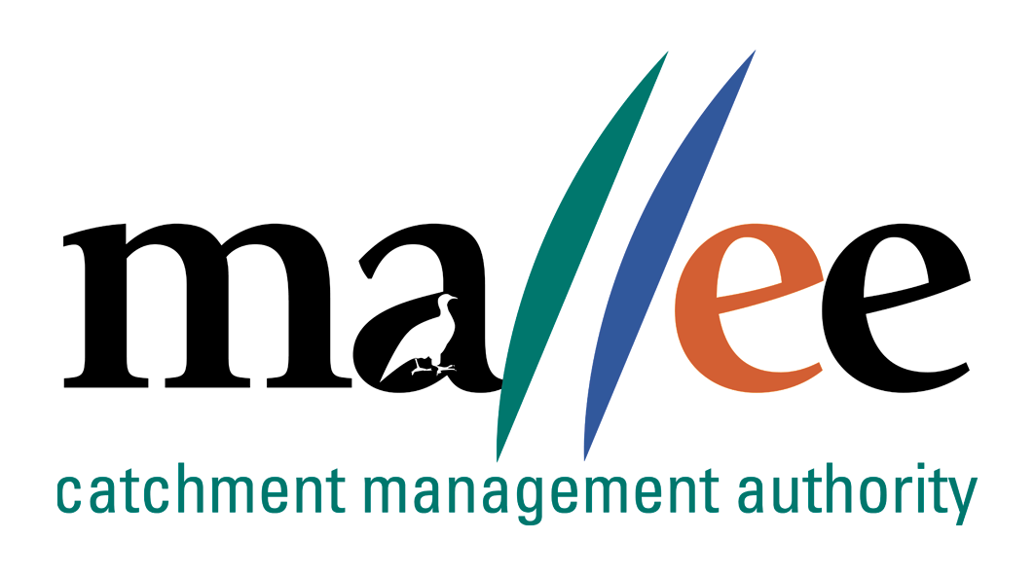 | APPLICATION FOR EMPLOYMENT FORM
Document Reference No: FORM 025-320

INTRODUCTION
Thank you for submitting an application for employment with Mallee Catchment Management Authority (CMA). Mallee CMA is committed to protecting the health, safety and well-being of all employees. In line with this objective an employee should not be required or permitted to undertake work for which they are not physically capable. You will need to read the Position Description in its entirety and consider your full physical capability to perform required activities as detailed. The following information forms part of Mallee CMA’s selection process and assists in providing a safe and healthy work environment.

VACANCY DETAILS
Position Name | Project Officer State Investment - Contractor Management and Reporting | Vacancy Ref No | 34/022
Position Details Sourced from | ☐ Seek ☐ Newspaper: Name  ☐ Mallee CMA Website ☐ Mallee CMA Social Media  ☐ Water Careers Website ☐ NRM Jobs Website  ☐ Other (please specify) ___________________

APPLICANT DETAILS
Title |  | Gender | ☐ Man ☐ Woman  ☐ Self-Described
Surname |  | Given Names
Preferred Name |  | Australian Citizen / Permanent Resident | ☐ Yes ☐ No  If no: Right to work in Australia documents attached
Postal Address
City/Town
State |  | Post Code
Phone Number |  | Mobile Number

REFERENCES (Please provide at least 2 professional contacts whom you have been a direct report. Include Name, Position, Title, Company and Phone number)
REFEREE 1 | REFEREE 2

DIVERSITY & INCLUSION DEMOGRAPHICS
Do you identify with any of the following: | ☐ Have a disability  ☐ Of Aboriginal and/or Torres Strait Islander background  ☐ Born Overseas – which country_______________  ☐ Speak a language other than English at home  ☐ LGBTIQ

ACKNOWLEDGEMENT & AUTHORISATION
If selected for employment, are you willing to complete the following pre-employment screening, which may include but not limited to:  - Confirmation of identity  - Medical declarations  - Medical checks  - Conflict of interest declarations  - Reference checks  - National Criminal History Checks (Police Checks)  - Conduct history checks  - Psychometric or aptitude testing | ☐ Yes ☐ No
Do you have a pre-existing injury or condition which may affect your ability to perform the requirements of the role? (refer to the position description for details of the role). | ☐ Yes ☐ No  If Yes please provide details:
Are you aware of any potential conflict of interest that may arise during the recruitment process and/or potential employment? | ☐ Yes ☐ No  If Yes please specify:
Are you willing to provide proof of COVID vaccination status? | ☐ Yes ☐ No  If No please provide details:
I certify that all the answers given herein are true and complete to the best of my knowledge | ☐ Yes

Important to Note: The Workplace Injury Rehabilitation and Compensation Act 2013 allows Mallee CMA to request that you disclose any:
- pre-existing injuries, illnesses or diseases that you have suffered, or
- existing injuries, illnesses or diseases that you continue to suffer, which could be accelerated, exacerbated, aggravated or caused to recur or deteriorate by your performing the responsibilities associated with the employment for which you applying.

Where you have a pre-existing condition, consideration will be given to reasonable modification to the environment or tasks (if at all possible or practicable) with the sole intention to protect, monitor and maintain your well-being during the course of your employment with Mallee CMA.

In accordance with the Public Administration Act 2004 section 33 and 34, the consequences of providing false or misleading information during application is termination of employment.

APPLICANT SIGNATURE
Name: |  | Date
Signature:

File Action: HR Personnel file

