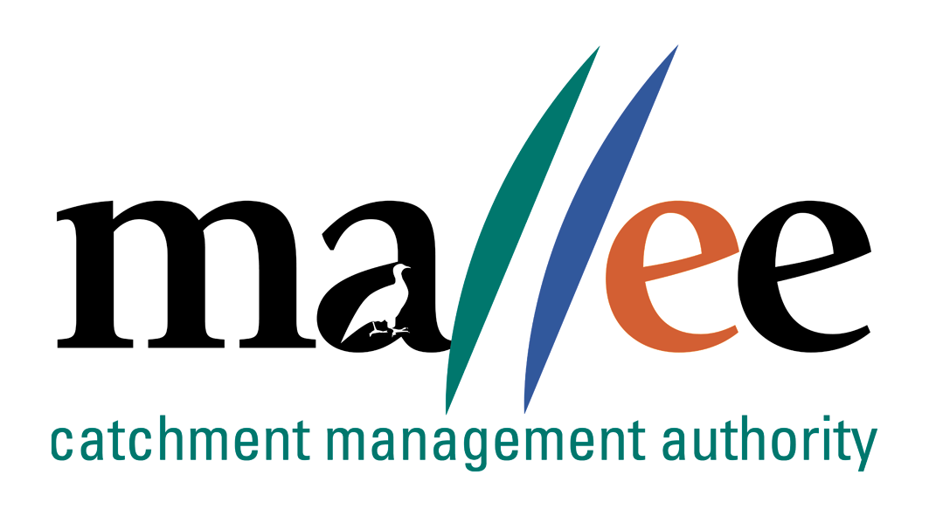 | APPLICANT RESPONSE FORM
Document Reference No: 025-321-FORM
Job Application Form
Please complete this form as part of your application.
In addition to this form you will also need to include a covering letter, a resume outlining education, employment history, copies of certificates / qualifications / licenses (as identified in the position description), details of 2 professional referees and any additional information relevant to the position.
You are encouraged to read the position description prior to completing this form. Reponses should include relevant and concise detail of how your current skills, attributes, knowledge and qualifications enable you to successfully fulfil the requirements of the position.
A maximum of 4 pages is preferred.
Position details
Vacancy reference number | 34/022
Position title | Project Officer State Investment - Contractor Management and Reporting
Position location | Mildura
Applicant details
Name:
Email address:
Please note – all correspondence in relation to this application will be sent to your email address
Phone number:

Template to use in requesting address of KEY SELECTION CRITERIA (KSC)
Please provide a specific response to the following selection criteria:

KSC1: Please explain the key elements of project management? Please explain your experience and skills in project management of environmental programs?

KSC2: Please explain your experience in monitoring, evaluation and Reporting and why it is so important in project managementt?

KSC3: Please explain how would you deliver on your output obligations when there isn't enough money to meet all of the contractual demands?

KSC4: Please explain your experience and demonstated skills in writing detailed/high level reports and
funding proposals;such as investor reports.

KSC5: Please explain your experience in stakeholder engagement, including specific examples of
Building and maintaining community and key stakeholder relationships on a particular Natural
Resouce Management project.

