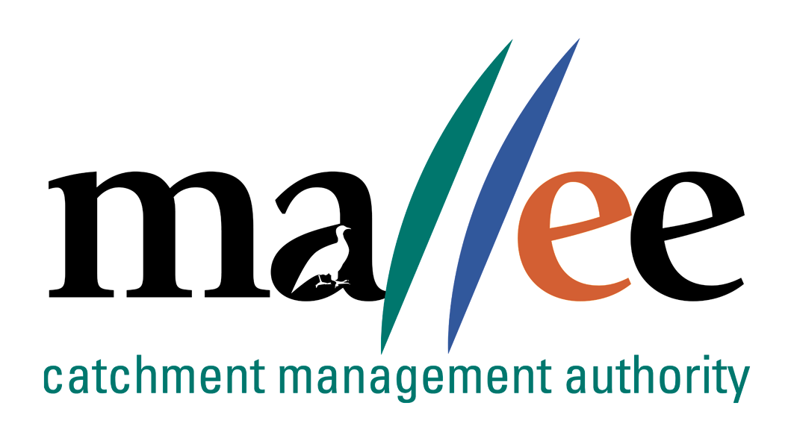 | APPLICANT RESPONSE FORM
Document Reference No: 025-321-FORM
Job Application Form
Please complete this form as part of your application.
In addition to this form you will also need to include a covering letter, a resume outlining education, employment history, copies of certificates / qualifications / licenses (as identified in the position description), details of 2 professional referees and any additional information relevant to the position.
You are encouraged to read the position description prior to completing this form. Reponses should include relevant and concise detail of how your current skills, attributes, knowledge and qualifications enable you to successfully fulfil the requirements of the position.
A maximum of 4 pages is preferred.
Position details
Vacancy reference number | 33/022
Position title | Manager Environmental Water
Position location | Mildura
Applicant details
Name:
Email address:
Please note – all correspondence in relation to this application will be sent to your email address
Phone number:

Template to use in requesting address of KEY SELECTION CRITERIA (KSC)
Please provide a specific response to the following selection criteria:

KSC1 Demonstrated understanding of project and contract management including project planning, financial management, project monitoring, evaluation and reporting.

KSC2 Demonstrated ability to lead and motivate staff/collaborators, and to build productive working relationships and high performing teams.

KSC3 Demonstrated analytical and conceptual skills with capacity to investigate issues, develop options, make recommendations, formulate policy and provide advice, specifically in a natural resources sector.

KSC4 Ability to persuade, convince or negotiate with clients, members of the public, other employees and persons in other organisations in the pursuit and achievement of specific and set objectives.

KSC5 Demonstrated experience in development and management of projects to deliver ecological improvements and knowledge of environmental water management.

KSC6 Demonstrated skills in communication, negotiation and conflict resolution and ability to represent the Mallee CMA as a professional with a client focused approach.

File action: Human resources application file

