ABN: 27 811 602 364 | In partnership with
ON-GROUND WATERWAY WORKS
ANGLER PARTNERSHIPS PROGRAM
EXPRESSION OF INTEREST FORM
009-013-FORM

The Mallee Catchment Management Authority, with support from the Victorian Government, has committed to providing funding over three years (2021/22 to 2023/24) for the Angler Partnership Program. The funding will be used for partnerships between Mallee CMA and recreational angling groups to deliver riparian and in stream improvement works in areas of local priority for anglers. Individual recreational anglers and any local group/club may also express interest in becoming involved.

Activities are to be performed in riparian areas as per the attached maps.

Following is a list of possible ideas for the funding, but is not exclusive;

- Pest plant and animal control in the riparian zones
- Creating instream habitats
- Stocking of recreational and native fish species
- Revegetation of riparian areas
- Improved access to local angler priority sites
- Education program
- Signage e.g. regulations NSW, Vic, species ID, cultural significance.
- Fencing / Bollarding
- Research on threatened species.

Expressions of Interest will be evaluated against the following criteria:

- Contribution to riparian habitat and environmental assets
- Value for money
- Ability to meet timelines
- Community value
- Project approach
- Demonstration of Social and Sustainable practices
- Alignment to Fisheries Management Priorities in the Mallee Waterway Strategy 2014-22

INSTRUCTIONS

- Due date of lodgement of this form is no later than COB 8 November 2021. If your completed Expression of Interest Form is not received by this date it may not be considered.

- Please discuss the prerequisites, conditions and confirm eligibility with your Mallee Catchment Management Authority Project Manager (listed below) before filling out this form.

- Please submit this form with required attachments to:

Kimberly Bale
Re: Expression of Interest form – Angler Partnerships Program
Mallee Catchment Management Authority

 | Post | OR | Email
 | PO Box 5017  Mildura VIC 3502 |  | kimberly.bale@malleecma.com.au

For further information, contact:

Kimberly Bale
Project Officer Planning and Approvals

Phone: 0418 845 287
Email: kimberly.bale@malleecma.com.au

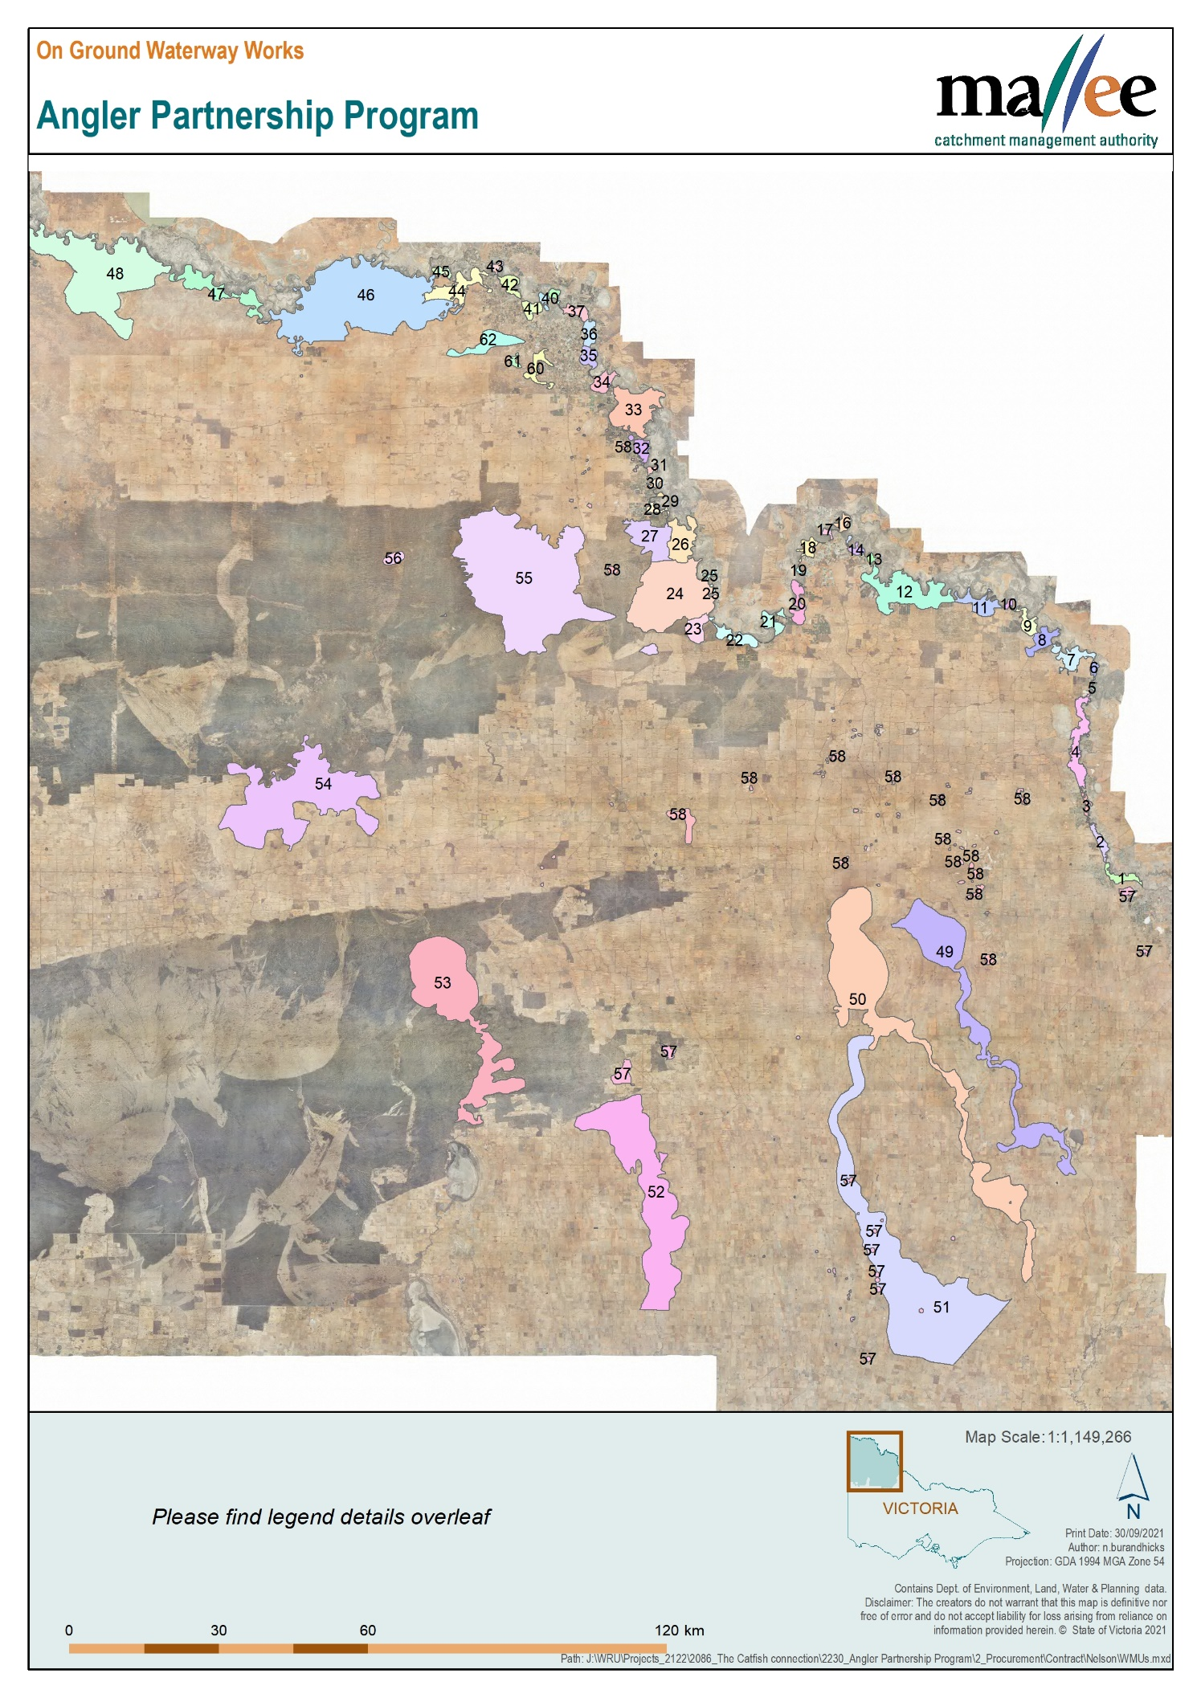

Legend
01. Vinifera | 32. Spences Bend
02. Nyah | 33. Karadoc
03. Piangil | 34. Bottle Bend
04. Burra Creek | 35. Psyche and Woorlong
05. Major Mitchells Lagoon | 36. Kings Billabong
06. Kenley North | 37. Mildura
07. Piambie | 38. Lock Island
08. Heywoods Lake | 39. Chaffey Bend
09. Murrumbidgee Junction | 40. Johnstons Bend
10. Boundary Bend | 41. Lakes Hawthorn & Ranfurley
11. Tata Creek | 42. Merbein Common
12. Belsar and Yungera Islands | 43. Cowanna Bend
13. Margooya Lagoon | 44. Abbotsford Bend
14. Knights Bend | 45. Darling Junction
15. Walshes Bend | 46. Wallpolla Island
16. Bumbang Island | 47. Mulcra Island
17. Euston | 48. Lindsay Island
18. Gadsdens Bend | 49. Lalbert Creek
19. Happy Valley | 50. Tyrrell Creek
20. Carina Bend | 51. Dunmunckle
21. Pound Bend | 52. Yarriambiack Creek
22. Wemen / Liparoo | 53. Wyperfeld
23. Kramen | 54. Boinka Lakes
24. Hattah Lakes | 55. Raak Plain
25. Retail Island | 56. Rocket Lake
26. Chalka North | 57. Freshwater
27. Dry Lakes | 58. Saline - Natural
28. Watts Bend | 60. Cardross
29. Graces Bend | 61. Koorlong
30. Buxton Bend | 62. Wargan
31. Police Bend

CLIENT DETAILS
Full name
Business Name
ABN
Postal address
Suburb / Town |  |  |  | Postcode
Phone Number |  | Fax Number
Mobile Number |  | Email Address
Property Detail | Lot & Plan No.
 | Road Location & Block Number
 | Crown Allotment ID
 | Are you the sole owner of the property? | ☐ Yes (continue to Property size)  ☐ No – select one:  ☐ Co-own ☐ Lease ☐ Share  ☐ Other (please describe):
 | Property Owner Details | Name
 |  | Address
 |  | Phone Number
Property size (Ha) |  | Area Applicable to Incentive (Ha)

Note: Please consider your incentive application in the context of the overall plan for your business.

- To the best of your knowledge, have you, or any previous owners of this property received any government incentive/s for works on this property?

Yes ☐ No ☐

If yes, please specify what incentive(s) and what year this occurred (if known)

……………………………………………………………………………………………………………..

INCENTIVE DETAILS

- Please provide detail on the incentive type/s you are applying for.

Incentive Type | Requested Amount ($) (incl. GST) | In-kind Contribution ($) (incl GST) | Works Details  (e.g. species treated, area treated, control methods, length of fencing) | Delivered by contractor (Yes/No) | Total ($) (incl. GST)
Revegetation

Pest Plant Control
Education program
Restocking of fish species
Creating instream habitats
Other (please specify)

Total ($) (GST incl.)

Please attach a map of your property detailing the site(s) where your intended works will take place. Please make sure this map has roads and landmarks marked so that it is easily recognised.
OR
Please draw a map of your property detailing the site(s) where your intended works will take place in the box below. Please make sure this map has roads and landmarks marked so that it is easily recognised.

- When will the works approximately start and be completed?

Start Date |  | Completion Date

PERMITS AND APPROVALS

Native vegetation written approval.
If the treatment of pest plants and animals is proposed to take place by removing or destroying native vegetation, a written agreement must be provided by the Department of Environment, Land, Water and Planning (DELWP). Please contact Land Planning and Approvals on (03) 5051 4500 to obtain an application form

- Has written approval for the removal been obtained and attached to this application?
☐ Yes ☐ No – Please provide explanation below ☐ N/A

EVALUATION

Expressions of Interest are assessed against the following evaluation criteria. (OFFICE USE ONLY)

 | Criteria
1 | Contribution to riparian habitat and environmental assets
2 | Value for money
3 | Ability to meet timelines
4 | Community value
5 | Project approach
6 | Alignment to Fisheries Management Priorities in the Mallee Waterway Strategy 2014-22

(OFFICE Copy)
DECLARATION

I, ………………………………………………………… have read and understand the prerequisite(s) and condition guidelines that support this form. I declare that the information given in this claim for incentives is correct. I understand that deliberately giving false or misleading information is a serious offence which will automatically lead to the cancellation of any incentive; and, that the Mallee Catchment Management Authority can substantiate the information contained within. Failure to complete this form will render this application ineligible for the described incentives.

I understand personal information is protected under the Victorian Privacy and Data Protection Act 2014. The purpose of collecting the information on this Expression of Interest form is to process your application for an incentive. The expressions of interest are to be prioritised and therefore incentives are not guaranteed until I receive official notification.

If my application is successful, I am unable to transfer this incentive to any other part of my property for any other works other than the incentive I am given, nor can I transfer this incentive to any other property I might own.
Please contact your Project Manager if you wish to review this application.

Incentives are not transferable either to another property or to another incentive type.

CHECK LIST

Completed ALL questions
A map of your property detailing the site(s) where your intended works will take place.
Permission from Property Owner/s obtained

Signed by the person applying for the incentive:

…………………………………………………………… (Applicant Name - print)

…………………………………………………………… (Signature)

Date: ………/………/………

Acknowledgement of receipt Grants/Incentives Registration Number:

Date EOI Received: ………/………/………

Office Use Only

Evaluated and approved ☐ Yes ☐ No

Manager Signature:

(YOUR Copy)
DECLARATION

I, ………………………………………………………… have read and understand the prerequisite(s) and condition guidelines that support this form. I declare that the information given in this claim for incentives is correct. I understand that deliberately giving false or misleading information is a serious offence which will automatically lead to the cancellation of any incentive; and, that the Mallee Catchment Management Authority can substantiate the information contained within. Failure to complete this form will render this application ineligible for the described incentives.

I understand personal information is protected under the Victorian Privacy and Data Protection Act 2014. The purpose of collecting the information on this Expression of Interest form is to process your application for an incentive. The expressions of interest are to be prioritised and therefore incentives are not guaranteed until I receive official notification.

If my application is successful, I am unable to transfer this incentive to any other part of my property for any other works other than the incentive I am given, nor can I transfer this incentive to any other property I might own.
Please contact your Project Manager if you wish to review this application.

Incentives are not transferable either to another property or to another incentive type.

CHECK LIST

Completed ALL questions
A map of your property detailing the site(s) where your intended works will take place.
Permission from Property Owner/s obtained

Signed by the person applying for the incentive:

…………………………………………………………… (Applicant Name - print)

…………………………………………………………… (Signature)

Date: ………/………/………

