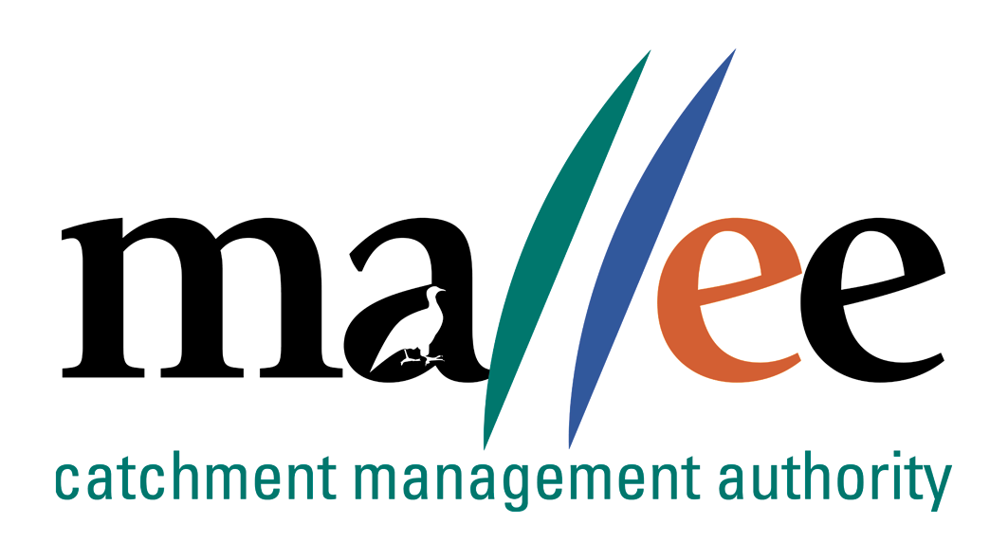 | FREEDOM OF INFORMATION APPLICATION FORM
FORM 046-323
Under the Freedom of Information Act 1982 (Vic) (FOI Act), every person has the right to request access to documents held by Victorian public sector agencies and Ministers. This right of access is subject to exceptions and exemptions necessary to protect essential public and private interests.
Making a valid request
Under section 17 of the FOI Act, a request must meet three requirements to be valid:
- your request must be in writing;
- you must provide sufficient information about the documents you are requesting to enable us to identify and locate relevant documents; and
- you must pay the application fee, or if payment of the application fee would cause you hardship you can request us to waive the fee in full or in part.
For more information on how to make a valid freedom of information (FOI) request, visit the Office of the Victorian Information Commissioner’s (OVIC) website www.ovic.vic.gov.au.
After you submit a request
After you submit a request, we will assess it to ensure it meets the requirements outlined in section 17 of the FOI Act. If we determine that your request is not valid, we will notify you within 21 days from the date we received your request and provide you with assistance to help you make the request valid. If your request is valid, we will begin processing it.
Timeframes
We have 30 days from the date you make a valid request to provide you with a decision. However, we can extend this time by up to 15 days if we need to consult with third parties whose information may be contained in the requested documents. We may also extend this time by up to 30 days with your agreement. We will let you know if the timeframe changes.
Other charges
We may require you to pay certain charges before access is provided to the requested document(s). For example, we may charge for providing copies of the document(s) or supervising an inspection of the document(s). If these charges exceed $50.00, we will notify you and request that you pay a deposit before proceeding with your request.
Collection, use and disclosure of your personal information
In accordance with the Privacy and Data Protection Act 2014, all personal information provided by you will only be used for the purpose of processing your Freedom of Information request. We will not use your personal information for any other purpose, and will not disclose it without your consent except as required by law.
Where information is required for statistical reporting purposes, all identifying details will be removed.
Your personal information is collected for the purpose of processing your request. We may notify and consult with third parties in considering whether an exemption under sections 29, 31, 31A, 33, 34 or 35 of the FOI Act applies. This may involve disclosing details such as your name, the terms of your request, and the documents falling within the scope of your request that concern the relevant third parties.
If necessary, we may transfer your request under section 18 of the FOI Act to another agency or Minister who is better placed to handle your request. We will tell you if we do this.
- Contact details

Your details
Title: |  |  |  | First Name(s): |  |  |  |  |  | Surname:
Organisation (if applicable):
Email address:
Contact number(s):
Postal address:
Suburb: |  |  |  |  | State/Territory: |  |  |  |  |  |  | Postcode:
Preferred contact method:
Do you need an interpreter? |  |  |  |  |  | If yes, what language?

Details of your representative (if applicable)

If you are using a representative like a parent, guardian, lawyer or any other person who is acting on your behalf, please advise who they are. If you are completing this form as the applicant’s representative, advise who you are.
Title: |  |  |  | First Name(s): |  |  |  |  |  | Surname:
Organisation (if applicable):
Email address:
Contact number(s):
Postal address:
Suburb: |  |  |  |  | State/Territory: |  |  |  |  |  |  | Postcode:
Preferred contact method:
Relationship to applicant:
Your authority for representative to act (if applicable)
Please complete this section if a representative is assisting you with your request and attach a certified copy of your photo identification with this authority to act.
I give permission and authorisation for my representative to act on my behalf and have access to any information concerning my request.
Applicant Name: |  |  |  |  |  |  |  | Representative Name:
Signature: |  |  |  |  |  |  |  | Signature:
Date: |  |  |  |  |  |  |  | Date:
Witness Name: |  |  |  |  |  |  |  | Witness Signature:

- The documents you are requesting access to
Please identify, describe or outline the document(s) you are seeking access to.
Your request must provide sufficient information for us to be able to identify and locate all relevant document(s). When writing your request, be specific about which document(s) you are seeking and include as much information as possible. Think about:
- what the document(s) relate to (for example, a complaint you made, or a particular project);
- the date range in which the document(s) may have been created;
- where the document(s) might be located (for example, in a particular email account, with a specific person, or held by a business or work unit); and
- the type of document(s) you seek (for example, an email, report, CCTV footage).
Please avoid using wording such as ‘all documents’ because your request may end up being too large for us to process, or it may not be specific enough for us to identify the document(s). If you are not sure how to frame your request, please contact us.
- Additional information to assist us
Optional: please provide background or contextual information to assist us in processing your request. This could include your reasons for seeking access to the document(s) and what you intend to do with the document(s). Providing additional information may assist us to identify and locate document(s) relevant to your request. It may also assist us to identify other ways you may access the requested document(s) outside of the FOI Act.
It may be helpful to exclude certain documents or information from your request if it isn’t particularly necessary or relevant. This may allow us to process your request more quickly by potentially reducing the number of documents to assess or removing the requirement for us to consult with third parties. Do you require access to:
- draft documents ☐ Yes / ☐ No
- duplicate documents: ☐ Yes / ☐ No
- commercial information relating to third parties: ☐ Yes / ☐ No
- personal information relating to third parties: ☐ Yes / ☐ No
- Proof of identification (if applicable)
If the documents you are seeking access to relate to you personally, you may need to provide us with a certified copy of your identification. We may not be able to provide access to the requested document(s) if we cannot verify that you are the person the subject of the document(s).
- Edited copies
The document(s) you requested may contain exempt or irrelevant information. Under section 25 of the FOI Act, we can provide edited copies of document(s) with exempt or irrelevant information removed. However, we are only required to do this if you indicate you will accept an edited copy of the document(s), and if it is practicable for us to make edits. If you don’t agree to receive an edited copy, we may decide the entire document is exempt and refuse access to it in full, even if there is some information that could be released to you.
☐ I agree / ☐ I do not agree to receive access to a copy of a document with exempt or irrelevant information removed in accordance with section 25 of the FOI Act.

- Form of access
Please tell us how you would like to receive a copy of the document(s) we decide to release to you. This might be inspecting the document(s), a hardcopy sent by post, a copy sent by email, the document(s) copied onto a CD or USB to be picked up or sent by post. We will try to accommodate your request but may have to provide access in another way.
- Application fee
The application fee for making a request for access under section 17 of the FOI Act is $30.10.
You can pay the application fee by Cheque/Money order payable to Mallee CMA, or Direct Deposit (details available on request).
Alternatively, if paying the application fee would cause you hardship, you may request that we waive the application fee in full or in part. If you request a waiver, please provide evidence to show why paying the fee would cause you hardship, such as a concession or healthcare card, bank statement, or statutory declaration outlining why payment would cause hardship. We will assess your fee waiver request and let you know the outcome.
- Submitting your request
You can send your request by email or post. If you are unable to send your request via these methods, please contact us to discuss other options.
Email: FOI@malleecma.com.au
Post: Freedom of Information Team
Mallee Catchment Management Authority
PO Box 5017, Mildura VIC, 3502
Further assistance
If you have a question about making a request or want to discuss your request further, please contact us on (03) 5051 4377 or FOI@malleecma.com.au.

