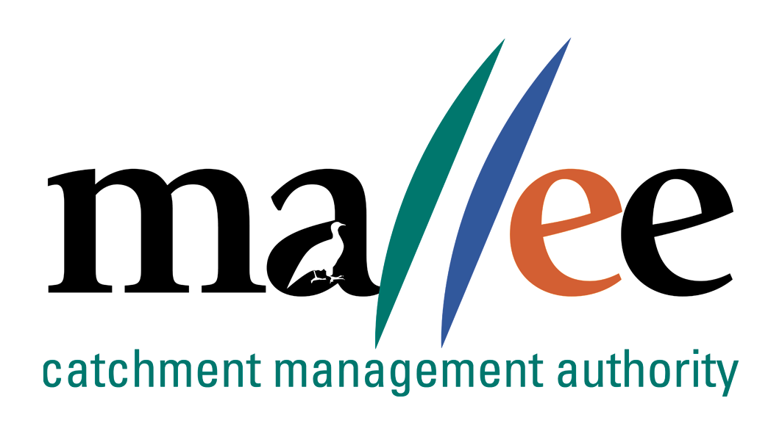 | APPLICANT RESPONSE FORM
Document Reference No: 025-321-FORM
Job Application Form
Please complete this form as part of your application.
In addition to this form you will also need to include a covering letter, a resume outlining education, employment history, copies of certificates / qualifications / licenses (as identified in the position description), details of 2 professional referees and any additional information relevant to the position.
You are encouraged to read the position description prior to completing this form. Reponses should include relevant and concise detail of how your current skills, attributes, knowledge and qualifications enable you to successfully fulfil the requirements of the position.
A maximum of 4 pages is preferred.
Position details
Vacancy reference number | 22/002
Position title | Manager Salinity and Irrigation
Position location | Mildura
Applicant details
Name:
Email address:
Please note – all correspondence in relation to this application will be sent to your email address
Phone number:

Template to use in requesting address of KEY SELECTION CRITERIA (KSC)
Please provide a specific response to the following selection criteria:

KSC1: Degree qualification in Science, Environmental Management, Natural Resource Management (NRM), Engineering, Geology or a related discipline and substantial experience in a similar role.

KSC2: An understanding of Salinity and how it relates to river, floodplain management and primary industries. Experience in this area will be an advantage.

KSC3: Demonstrated experience in program, project management, and contract management with a focus on delivering operational and outcomes.

KSC4: Management of business unit budgets and the production of high quality reports and advice to the organisation’s Board and key stakeholders is essential.

KSC5: Demonstrated management experience with the ability to ensure complex projects and reporting requirements are maintained to a high standard.

KSC6: Leadership experience that demonstrates how to drive a positive workplace culture while maintaining professional standards of accountability.

File action: Human resources application file

