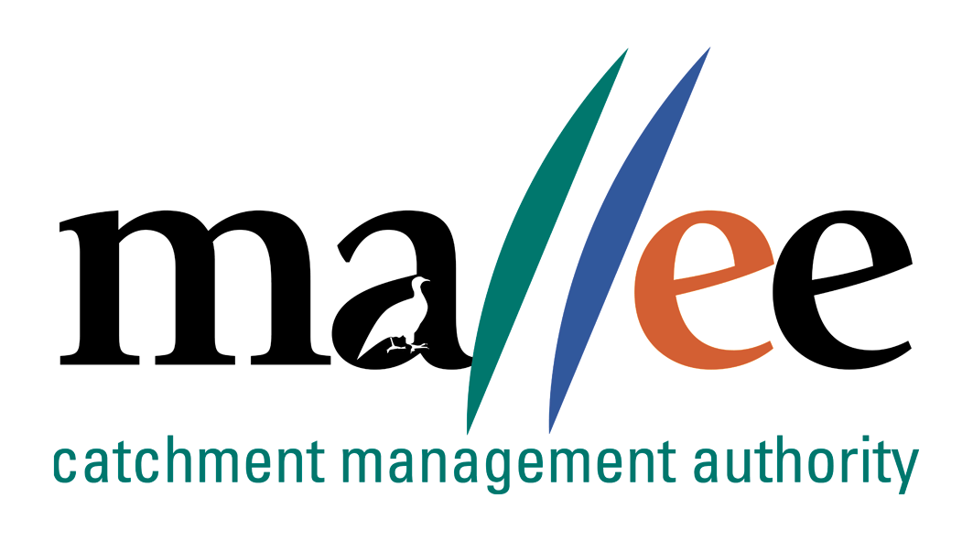 | APPLICANT RESPONSE FORM
Document Reference No: CMA 321 FORM

Job Application Form
Please complete this form as part of your application.
In addition to this form you will also need to include a covering letter, a resume outlining education, employment history, copies of certificates / qualifications / licenses (as identified in the position description), details of 2 professional referees and any additional information relevant to the position.
Reponses must address the core capabilities, values and behaviours necessary to successfully fulfil the requirements of the position
- be a maximum of 4 pages
- be relevant and concise, dot points are acceptable

Position details
Vacancy reference number | 21/034
Position title | Floodplain Approvals Project Officer
Position location | MILDURA, Victoria
Applicant details
Name:
Email address:
Please note – all correspondence in relation to this application will be sent to your email address
Phone number:

Template to use in requesting address of SHORT ANSWER QUESTIONS
Applicants are to respond to the following questions:

Q1.Please explain your experience in Natural Resource Management (NRM), including flood and waterway behaviour in the context of inland waterways. Explain your experience in providing advice and support for emergency events.

Q2. Please explain you experience in delivering on Statutory approvals; including permits, referrals and
advice associated with waterway and floodplain management.

Q3. Provide evidence of you demonstrated understanding in analytical and conceptual skills with capacity
to investigate issues, develop options, make recommendations, formulate policy and provide advice.

Q4. Please explain your expereince and skills in project management of environmental programs?

Q5: Explain your experience in highly developed communication and interpersonal skills demonstrating
high quality written and oral presentation skills including the ability to establish rapport and negotiate
clear outcomes with service delivery partners, key government agencies and technical specialists.

Q6. Please explain your experience and demonstated skills in writing detailed/high level reports and
funding proposals;such as investor reports.

File action: Human resources application file

