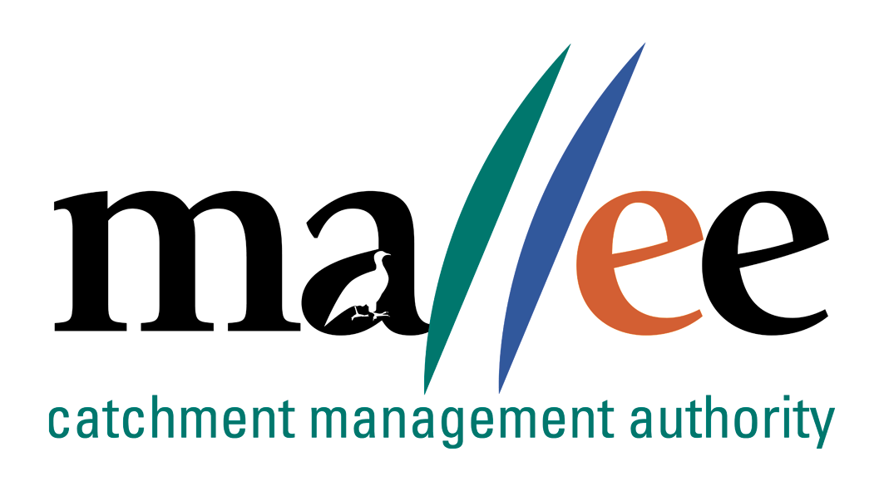 | APPLICANT RESPONSE FORM
Document Reference No: CMA 321 FORM

Job Application Form
Please complete this form as part of your application.
In addition to this form you will also need to include a covering letter, a resume outlining education, employment history, copies of certificates / qualifications / licenses (as identified in the position description), details of 2 professional referees and any additional information relevant to the position.
Reponses must address the core capabilities, values and behaviours necessary to successfully fulfil the requirements of the position
- be a maximum of 4 pages
- be relevant and concise, dot points are acceptable

Position details
Vacancy reference number | 21/035
Position title | Program Coordinator Waterways and Wetlands
Position location | MILDURA, Victoria
Applicant details
Name:
Email address:
Please note – all correspondence in relation to this application will be sent to your email address
Phone number:

Template to use in requesting address of SHORT ANSWER QUESTIONS
Applicants are to respond to the following questions:

Q1: Please explain the key elements of project management? Please explain your expereince and skills in program and project management of environmental programs?

Q2. Please explain your experience in monitoring, evaluation and Reporting and why it is so important in project managementt?

Q2: Please explain what experience you have with financial/output budget management? How would you
deliver on your output obligations when there isn't enough money to meet all of the contractual demands?

Q3. Please explain your experience and demonstated skills in writing detailed/high level reports and
funding proposals;such as investor reports.

Q4: Please explain your experience in leading and managing staff and what are your leadership strengths
and weaknesses?

Q5: Tell me about a time you persuaded others to accept your idea when diametrically opposite from the
start of the negotiation?

File action: Human resources application file

