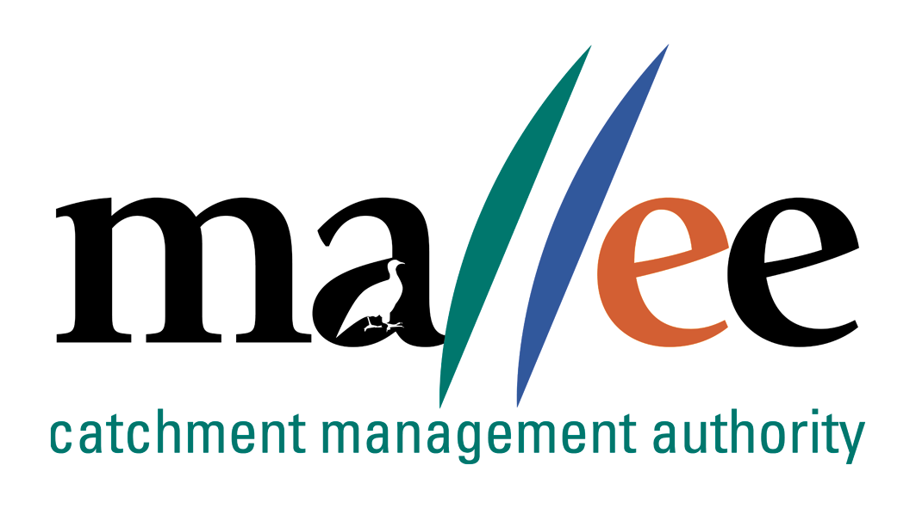 | APPLICANT RESPONSE FORM
Document Reference No: CMA 321 FORM

Job Application Form
Please complete this form as part of your application.
In addition to this form you will also need to include a covering letter, a resume outlining education, employment history, copies of certificates / qualifications / licenses (as identified in the position description), details of 2 professional referees and any additional information relevant to the position.
Reponses must address the core capabilities, values and behaviours necessary to successfully fulfil the requirements of the position
- be a maximum of 4 pages
- be relevant and concise, dot points are acceptable

Position details
Vacancy reference number | 21/020
Position title | Contract and Business Support Officer
Position location | Mildura
Applicant details
Name:
Email address:
Please note – all correspondence in relation to this application will be sent to your email address
Phone number:

SHORT ANSWER QUESTIONS
Applicants are to respond to the following questions:

Q1: Explain your previous experience or knowledge and how it relates to this position and any experience with government procurement processes

Q2: Describe your experience with developing and maintaining procurement processes and supporting documentation. Explain what documentation was involved?

Q3: How do you ensure good time management and prioritise your work when you have many tasks to complete?

Q4: Describe your recent experience with financial administration duties, corporate compliance, and record management.

Q5: This role includes the use of various Microsoft and corporate applications with attention to detail and ability to provide support to project officers. Can you outline your experience in using Microsoft office, teams and corporate applications for scheduling, invoicing , reconciliations and recordkeeping ?

File action: Human resources application file

