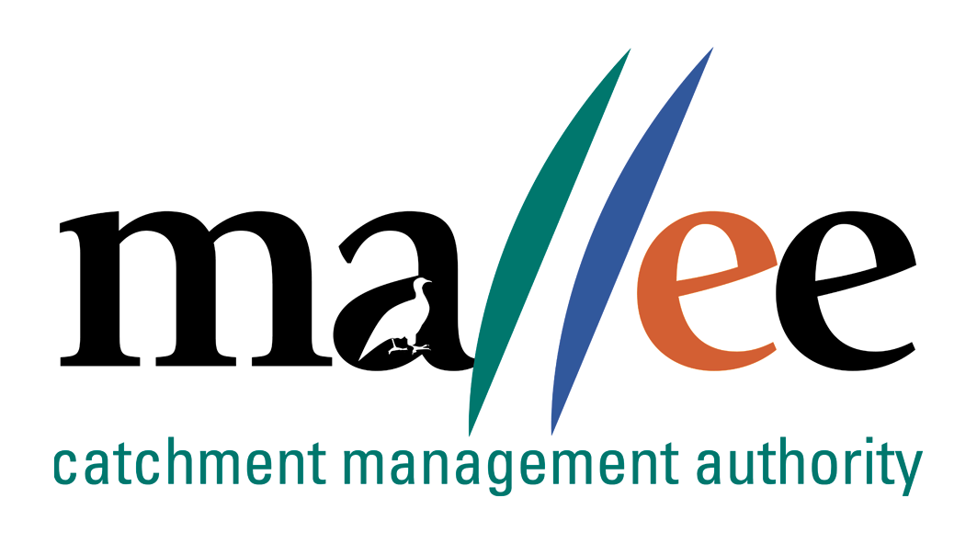 | APPLICANT RESPONSE FORM
Document Reference No: CMA 321 FORM

Job Application Form
Please complete this form as part of your application.
In addition to this form you will also need to include a covering letter, a resume outlining education, employment history, copies of certificates / qualifications / licenses (as identified in the position description), details of 2 professional referees and any additional information relevant to the position.
Reponses must address the core capabilities, values and behaviours necessary to successfully fulfil the requirements of the position
- be a maximum of 4 pages
- be relevant and concise, dot points are acceptable

Position details
Position title | Traditional Owner Project Officer
Position location | Mildura
Applicant details
Name:
Email address:
Please note – all correspondence in relation to this application will be sent to your email address
Phone number:

Template to use in requesting address of KEY SELECTION CRITERIA (KSC)
Please provide a specific response to the following selection criteria:

KSC1: Excellent communication skills and the ability to quickly build trust with other staff, stakeholders and community groups

KSC2: A demonstrated understanding of aboriginal culture, including an ability to describe values of waterways to aboriginal people and a working understanding of the customs/lore that should be followed when meeting with community to discuss management of country

KSC3: A demonstraded understanding of Aboriginal cultural heritage, what it is and obligations to protect it

KSC4: An understanding of issues affecting rivers, wetlands and floodplains in the Mallee CMA region

KSC5: Knowledge and experience using computers and software applications, particularly Microsoft products
KSC 6 Demonstrated experience woking unsupervised, self motivated and able to achieve results
for the business when working in the community

File action: Human resources application file

