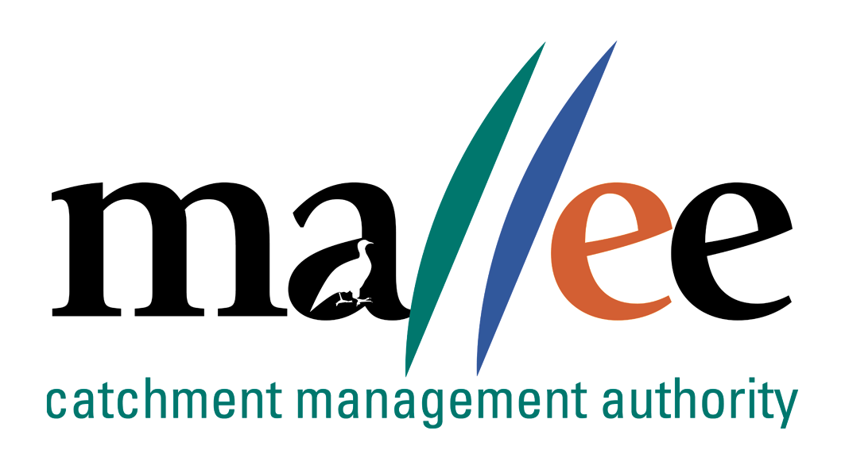 | APPLICANT RESPONSE FORM
Document Reference No: CMA 321 FORM

Job Application Form
Please complete this form as part of your application.
In addition to this form you will also need to include a covering letter, a resume outlining education, employment history, copies of certificates / qualifications / licenses (as identified in the position description), details of 2 professional referees and any additional information relevant to the position.
Reponses must address the core capabilities, values and behaviours necessary to successfully fulfil the requirements of the position
- be a maximum of 4 pages
- be relevant and concise, dot points are acceptable

Position details
Position title | Community Parterships Coordinator
Position location | Mildura
Applicant details
Name:
Email address:
Please note – all correspondence in relation to this application will be sent to your email address
Phone number:

Template to use in requesting address of KEY SELECTION CRITERIA (KSC)
Please provide a specific response to the following selection criteria:

KSC1: Excellent interpersonal, verbal and written communications skills.

KSC2: Previous experience working in a similar role.

KSC3 Highly developed interpersonal skills with the ability to build strong relationshipos

KSC 4 Experience in the use of social media tools and high level of creativity and initative

KSC 5 Proactive with a positive can do attitude

KSC 6 Experience in leading the development of high level communication plans, eg. Consultation Plans for Environmental Effects Statements and Environment Reports, as part of the environmental assessment process

KSC7: Ability to write accurate reports and program documents that meet audience needs and contain the necessary information to achieve their purpose.

KSC 8 Ability to liase with media and prepare material for public release to a wide range of audiences.

File action: Human resources application file

